**MySQL**

**Exercise 3**

1. Write a program containing a loop that iterates from 1 to 1000 using a variable *I*, which is incremented each time around the loop. The program should output the value of *I* every hundred iterations (i.e., the output should be 100, 200, etc.).

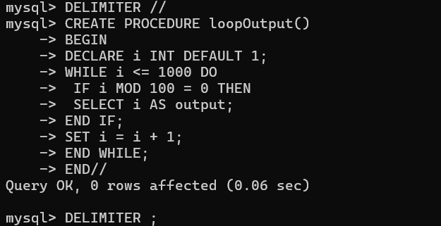

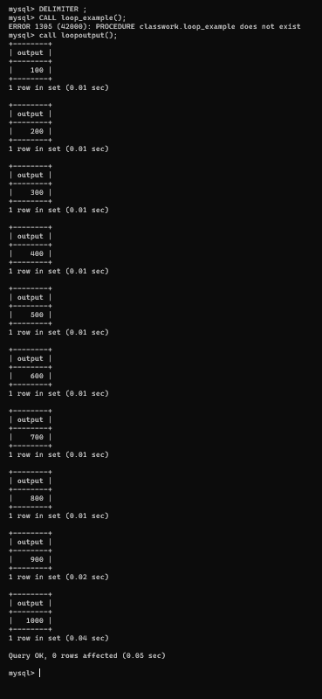

1. Write a program that examines all the numbers from 1 to 999, displaying all those for which the sum of the cubes of the digits equal the number itself.

## 

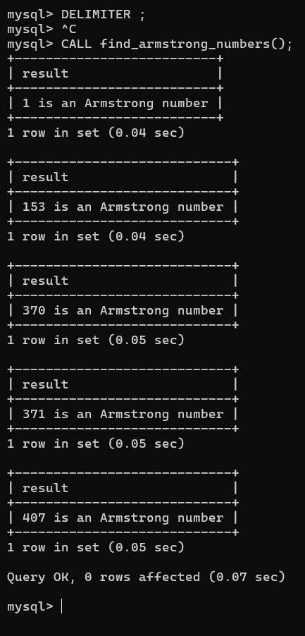

1. Write a program that Selects from any table a minimum and maximum value for a radius, along with an increment factor, and generates a series of radii by repeatedly adding the increment to the minimum until the maximum is reached. For each value of the radius, compute and display the circumference, area, and volume of the sphere. (Be sure to include both the maximum and the minimum values.).

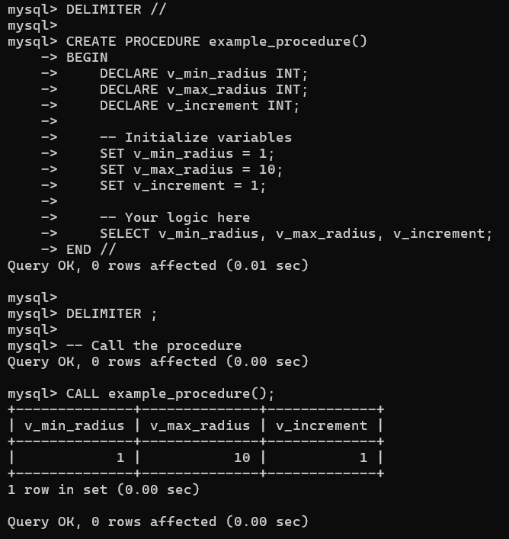

1. A *palindrome* is a word that is spelled the same forward and backward, such as *level*, *radar*, etc. Write a program to Selects from any table a five letter word and determine whether it is a palindrome.

ANS:

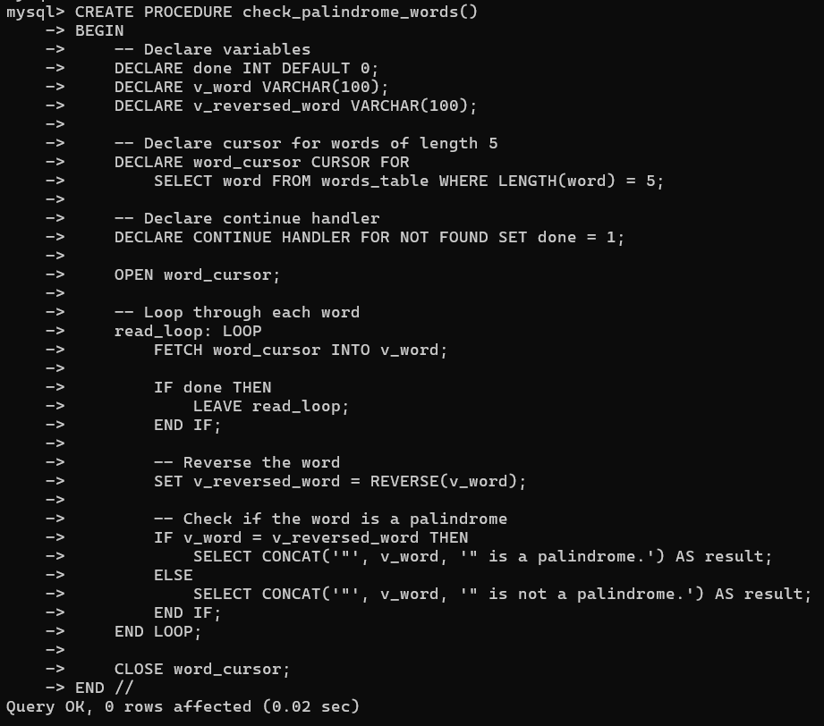

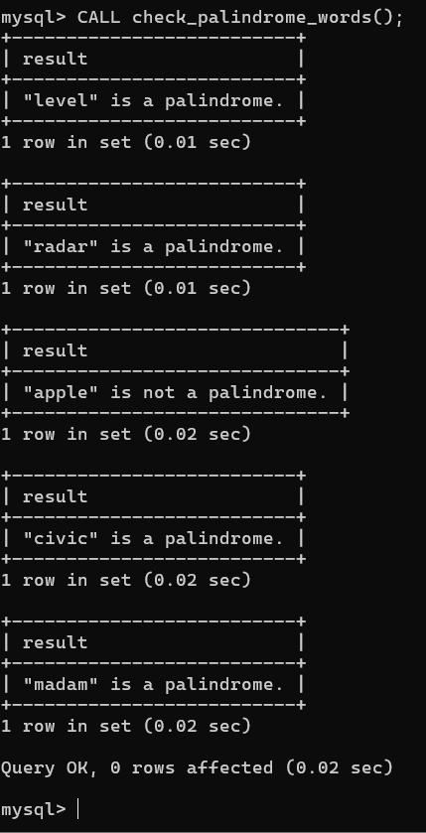

1. Modify the above program to Select from any table a variable length word. This requires determining how many characters are read in.

